
++144111111111111

EXCERPT FROM THE MINUTES OF THE CY 2025 – 39th REGULAR SESSION OF THE HONORABLE SANGGUNIANG BAYAN TIGBAUAN, ILOILO HELD AT THE S.B. SESSION HALL, TIGBAUAN MUNICIPAL BUILDING ON SEPTEMBER 24, 2025 AT 10:15 IN THE MORNING

PRESENT:
HON. PINKY A. JARINA - SB Member
HON. GENE ROSE C. CANAYA - SB Member
HON. ADRIAN S. CAMPOSAGRADO - SB Member
HON. JOEL L. SAYSON - SB Member
HON. MARLON R. TERUÑEZ - SB Member
HON. NORA ROSE T. TUBIANO - SB Member
HON. REYNALDO E. TUMABOTABO - SB Member
HON. NORBERTO T. TURALBA - SB Member
HON. LORNA T. DOMINGO - Liga President
HON. FLORENCE JOY V. CABALONGA - SKMF President

ABSENT:

HON. LUGEN T. ORTILANO, - Vice Mayor –(Special Priv. Leave)
- - - - - - - - - - - - - - - - - - - - - - - - - - - - - - - - - - - - - - - - - - - - - - - - - - - - - - - - - - - - - - - - - - - - - -
Resolution No. 2025-155

RESOLUTION AUTHORIZING ATTY. VIRGILIO T. TERUEL, MUNICIPAL MAYOR, TO SIGN FOR AND IN BEHALF OF THE MUNICIPAL GOVERNMENT OF TIGBAUAN, THE MEMORANDUM OF AGREEMENT (MOA) WITH ILOILO PROVINCIAL GOVERNMENT REPRESENTED BY HON. ARTHUR R. DEFENSOR, JR., GOVERNOR, REGARDING THE ZERO OPEN DEFECATION MOVEMENT OF ILOILO PROVINCE, FORMERLY KNOWN AS THE SANITARY TOILET FOR TOILET-LESS HOUSEHOLDS IN ILOILO PROVINCE-BATCH 8.
WHEREAS, the Local Chief Executive in a letter dated September 2, 2025 requested this Sangguniang Bayan for an URGENT passing of a Resolution Authorizing Atty. Virgilio T. Teruel, Municipal Mayor, to Sign for and in Behalf of the Municipal Government of Tigbauan, the Memorandum of Agreement (MOA) With Iloilo Provincial Government Represented by Hon. Arthur R. Defensor, Jr., Governor, Regarding the Zero Open Defecation Movement of Iloilo Province, Formerly Known as the Sanitary Toilet for Toilet-Less Households in Iloilo Province-Batch 8;
WHEREAS, said Memorandum of Agreement shall be made and entered into by, and between the following parties:
- THE ProvincIAL GOVERNMENT of Iloilo, a local government unit duly created under the laws of the Republic of the Philippines represented by Honorable Governor Arthur R. Defensor, Jr. with postal address at Provincial Capitol Bldg., Bonifacio Drive, Iloilo City referred to as the “PROVINCE”; and

- THE MUNICIPALITY OF TIGBAUAN, a local government unit duly created under the laws of the Republic of the Philippines represented by Honorable Mayor, Atty. Virgilio T. Teruel with postal address at Tejero St., Brgy. 9 (Pob.), Tigbauan, Iloilo, Iloilo, referred to as the “IMPLEMENTING LGU”;

WHEREAS, Open Defecation is the practice of defecating outside and not into a designated toilet. It is especially problematic in areas where people defecate in fields, rivers and open trenches. This behavior may be a result of cultural practices, the lack of access to toilets, or both. Improper excreta disposal is the principal factor in the transmission and spread of gastrointestinal infections including intestinal parasitism. It has been responsible for the contamination of water supply sources resulting to outbreaks of water-food borne diseases;

Page 2-Res. No. 2025-155
WHEREAS, eliminating open defecation is the main goal of improving access to sanitation in the community. Even if toilets are available, people need to be convinced to refrain from open defecation but instead use toilets. Therefore, the need for behavioral change is critical in addition to the provision of toilets;
WHEREAS, Zero Open Defecation focuses on assisting communities and individuals to understand the health risks associated with open defecation;
WHEREAS, in the Philippines, the Zero Open Defecation was launched to build on the momentum of the emergency response and reinvigorate progress towards the national goals of eliminating open defecation;
WHEREAS, the targets are at least 60% of barangays be declared zero open defecation by 2016 and achieving universal access to safe and adequate sanitation facilities by the year 2028
WHEREAS, the Province of Iloilo had actively campaigned this in the 42 municipalities and 1 component city to improve access of people to safe and adequate sanitation facilities
WHEREAS, as of November 2022, there were 43 out of 43 municipalities declared as Zero Open Defecation. The 1,721 or 100% of Barangays are practicing Zero Open Defecation;
WHEREAS, with the current scenario in Iloilo Province, there is a need to continue the campaign on Zero Open Defecation in reaching another ladder, the G2 status;
WHEREAS, in order to achieve the national goal, the Iloilo Provincial Government is helping the different barangays and municipalities by augmenting materials needed for construction of locally built latrines at the household level;
WHEREAS, for and in consideration of the above premises and of the mutual covenants stipulated hereinafter set forth, the PARTIES hereto agree to enter into this Memorandum of Agreement to adhere to the following terms and conditions:
- This project shall be known as the “ZERO OPEN DEFECATION MOVEMENT OF ILOILO PROVINCE” formerly known as “SANITARY TOILET for TOILETLESS HOUSEHOLDS in ILOILO PROVINCE-BATCH 8”;

- That the “PROVINCE OF ILOILO” will designate the Provincial Health Office to spearhead the implementation of this Project and to identify recipient Municipalities. That the Province of Iloilo thru the Project Management Committee composed of the Provincial Engineers Office, Provincial Planning and Development Office, Provincial Health Office, General Services Offices and Provincial Social Welfare and Development Office shall manage the overall implementation of the Movement for Zero Open Defecation Program of the Province of Iloilo.

- That the “PROVINCE OF ILOILO” will provide (1) toilet bowl, 2 bags of cement, 2 pcs. PVC Sanitary Pipes- 4inches in diameter, 2 pcs. PVC Sanitary Elbow- 4 inches’ diameter, 1 Solvent Cement and 1 PVC Toilet Flange with wax for every beneficiary.

- The Municipality and Barangay shall provide for the materials for their septic tank and other materials needed such as sand and gravel while the beneficiary shall be responsible for the labor and other needed materials to finish their toilet facility.

- That the Municipality and Barangay will provide Vehicle for the transport of materials from the Province of Iloilo.

- That the Province of Iloilo thru the Provincial Engineer Office will assist in the delivery of materials to the LGU concerned upon request or if LGU vehicle is not available.

- That the implementing LGU will receive (1) toilet bowl, 2 bags of cement, 2 pcs. PVC Sanitary Pipes- 4inches in diameter, 2 pcs. PVC Sanitary Elbow- 4inches diameter, 1 Solvent Cement and 1 PVC Toilet Flange with wax for every beneficiary.

- That implementing LGU thru their LGU team composed of their MSWDO, MHO, and Barangay Officials shall identify recipients approved by the mayor which shall then be validated by the PHO and the Project Management Committee on Zero open Defecation Movement of the Province of Iloilo if the list of beneficiaries met the criteria.

Page 3-Res. No. 2025-155

- That the Implementing LGU thru their LGU team will conduct an orientation/meeting to household recipients, what the project is all about and what the “PROVINCE OF ILOILO” expects from them as co-partners.

- That the recipient, the household head shall execute an agreement/kasugatanan accepting the Project and shall faithfully abide with the provisions stated therein especially on their counterpart of labor and other materials needed to construct their toilet facility. This agreement shall be witnessed by the Barangay Officials - Punong Barangay and the Municipal Health Officer or Representative as witness.

- That the implementing LGU thru their Municipal Health Office Representatives (Rural Health Midwife/Rural Sanitation Inspector), and with the Barangay Officials shall ensure and monitor the implementation of the project. They shall likewise submit weekly and monthly reports to PHO as to the status of the Project implementation and a final report of completion.

- That the implementing LGU shall ensure that correct quantity is received and maintained safely and good quality of materials are received to ensure that the Households were able to construct their sanitary toilets.

- In cases of Breakage, loss of materials, the municipal government shall be responsible for the replacement of said materials to ensure 100% construction.

- That the Province of Iloilo thru its monitoring team composed of Provincial Sanitation Inspectors, Provincial Engineers Office personnel, Provincial Planning and Development Office personal together with the Rural Sanitation Inspector, Rural Health Midwife, Barangay Health Worker and the Validation Team for Zero open Defecation Program shall conduct physical Inspection of toilets constructed.

- That the Province of Iloilo through the Provincial Health Office and the Project Management Committee shall review reports and confirm completion of project and submit report to the Governor of completed projects on a monthly basis.

- That the Municipal and Barangay Chief Executives are responsible and accountable for the overall implementation of this project such as proper handling, storage and replacement of damaged materials, provision of other required materials for the household that has no capacity to provide such, and facilitate transport of materials to respective barangays.

NOW, THEREFORE, on motion of HON. PINKY T. JARINA, Chairperson, Committee on Health and Sanitation and duly seconded by Hon. Gene Rose C. Canaya, Hon. Adrian S. Camposagrado, Hon. Joel L. Sayson, Hon. Nora Rose T. Tubiano, Hon. Reynaldo E. Tumabotabo, Hon. Norberto T. Turalba, Hon. Lorna T. Domingo and Hon. Florence Joy V. Cabalonga;
RESOLVED, to authorize Atty. Virgilio T. Teruel, Municipal Mayor, to Sign for and in Behalf of the Municipal Government of Tigbauan, the Memorandum of Agreement (MOA) With Iloilo Provincial Government Represented by Hon. Arthur R. Defensor, Jr., Governor, Regarding the Zero Open Defecation Movement of Iloilo Province, Formerly Known as the Sanitary Toilet for Toilet-Less Households in Iloilo Province-Batch 8;
RESOLVED FURTHER, to forward copies of this Resolution to the Office of the Municipal Mayor, Atty. Virgilio T. Teruel, to the Office of the Provincial Governor, Hon. Arthur R. Defensor, Jr. and all concerned for their information and/or appropriate action.

APPROVED.
CERTIFIED CORRECT:
MARLENE TAYO-NAVA
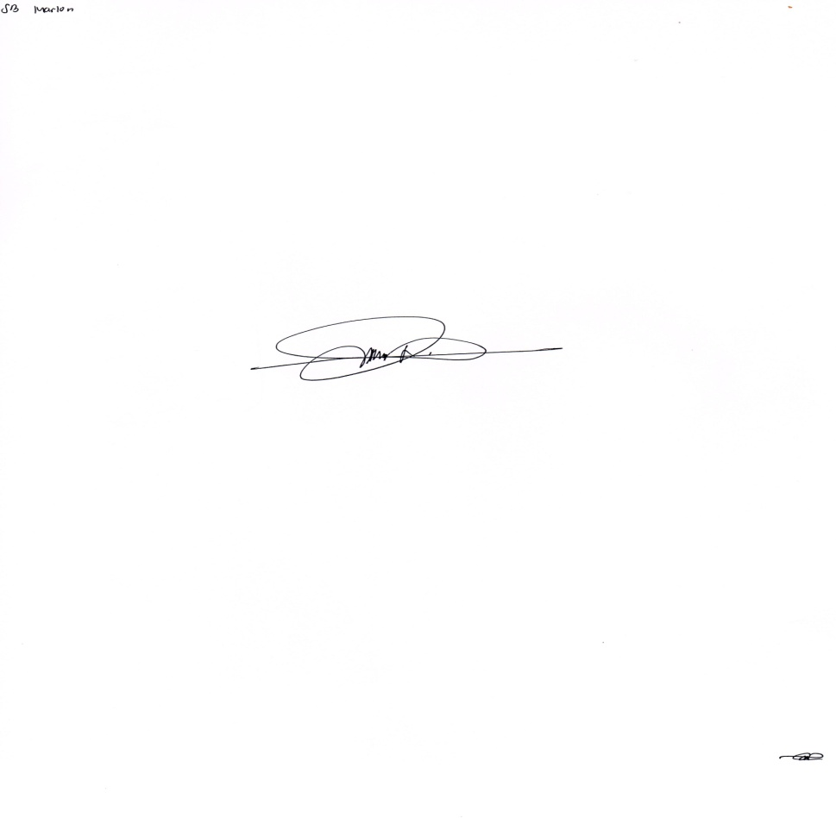
SB Secretary
ATTESTED:

MARLON R. TERUÑEZ
SB Member & Temporary Presiding Officer


